JOIN FREEDOM
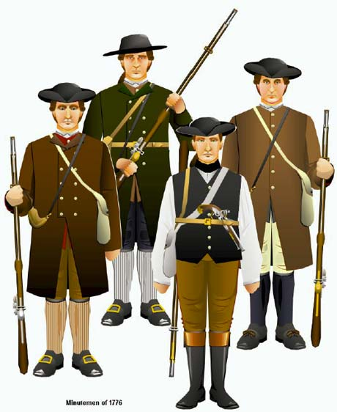  Minute Men are needed to defend our towns! |  | The Stamp Act  I’m a patriot because I’m against the stamp act. The stamp act is that they are putting tax on paper, wedding license, and ink.  The Quartering Act  Second, I have to house soldiers with my boss and I now have to lose most of my food portion and my bed and I have to wash dirty laundry that’s not mine.  Speaking out  Lastly, I want to have freedom of speech, and Sam Adams and John Hancock spoke out their mind and now they are going to be arrested because they did that.

It’s not too late to choose. Will you be a Patriot or a Tory? Become a Patriot and fight for your freedom by joining the Sons of Liberty!

Sons of Liberty meet at Sun Tavern
“Give Me Liberty or Give Me Death,” as Patrick Henry said.

